Simple Diagram of the Methylation Cycle
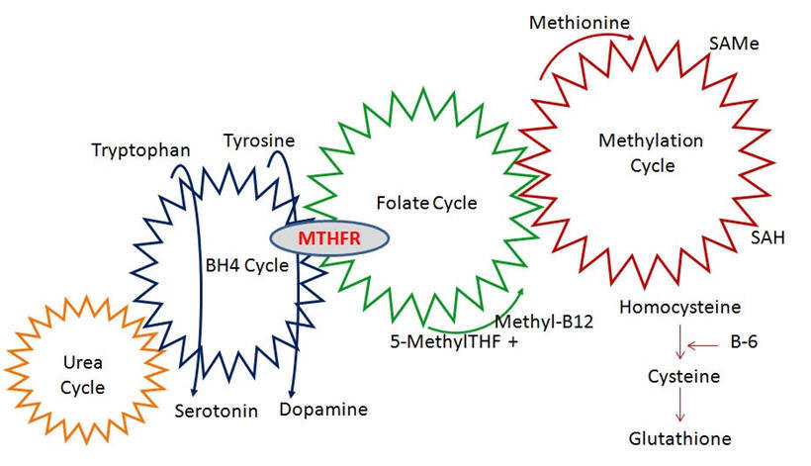

Complex Diagram of the Methylation Cycle
